DATA SCIENCE APPLIED TO ELECTRICAL SYSTEMS
Final Project
Politècnica de Catalunya (UPC), Barcelona
2025

Authors
Regules, Tabaré
Turrina, Davide
Zhang, Yemao

Table of Contents
Introduction 3
Objectives 3
Data 3
Methodology 4
Data collection, cleaning and preprocessing 4
Data collection 4
Data cleaning and preprocessing 4
Exploratory Data Analysis (EDA) 5
Feature engineering and selection 5
Selection 6
Clustering daily electricity price profiles 8
Application of PCA and comparison with the regression model 9
Findings 10
Exploratory Data Analysis (EDA) 10
Key findings 14
Machine Learning Model 15
Clustering Daily Electricity Price Profiles 18
PCA for the regression model 19
Conclusions 21
Challenges faced 21

Introduction

Objectives
The objective of this work is to analyze the Spanish electricity market using its data and machine learning techniques, so as to:
- Predict the day-ahead spot electricity price.
- Group daily electricity price profiles into clusters to identify patterns.
- Reduce data dimensionality and tests its effect on the models used.
For the above, a supervised learning model for forecasting the Spanish SPOT price is developed, at an hourly resolution. For patterns identification a unsupervised learning (clustering) technique is used and the dimensionality reduction is based on a principal component analysis and its effect on the regression model performance is evaluated.

Data
The present project is based on historical data from the Spanish electricity market obtained from the ESIOS Red Eléctrica de España (REE) website. The dataset includes hourly observations of:
- Day-ahead marginal electricity prices (€/MWh)
- Scheduled generation by technology:
  - Coal
  - Combined cycle (gas)
  - Wind
  - Solar photovoltaic (PV)
  - Hydraulic (hydro)
  - Nuclear
- Electricity demand and day-ahead allocated energy
- Calendar variables (hour of day, day of week, month)
The data used goes from September 2022 until August 2025, with a total of approximately 26,000 hourly observations.
Once the supervised learning model is designed, for its validation a separated test dataset corresponding to September 2025 is used, in accordance with the handout requirements. All forecasting models operate at an hourly granularity.

Methodology
The methodology followed in this work is structured around the three main tasks indicated before: supervised learning for price forecasting, unsupervised learning for pattern identification, and dimensionality reduction using PCA. The workflow consisted of:
- Data collection, cleaning and preprocessing
- Exploratory Data Analysis (EDA)
- Feature engineering and selection
- Supervised learning model development and validation
- Clustering daily electricity price profiles
- Principal Component Analysis (PCA)
- PCA-based regression and comparison
- Findings
- Conclusions
- Challenges faced

Data collection, cleaning and preprocessing

Data collection
The data used in this work was obtained from the ESIOS platform, which provides public access to historical information on the Spanish electricity system. Multiple datasets were downloaded directly in a CSV format. These datasets correspond to different market variables that were initially discussed and considered as potential useful features, including demand, generation by technology, market-cleared energy, and price information.
Each variable was provided as an independent time series, where all files were merged into a single unified dataset. This consolidated dataset served as the input for the project analysis and modelling stages. Once the unified CSV file was created, it was imported into the Jupyter notebook for its cleaning and preprocessing.

Data cleaning and preprocessing
After loading the consolidated dataset, several preprocessing steps were implemented so as to ensure that the input data is high quality and consistent. The first steps are crucial, in accordance with the rule of thumb “Trash in, trash out”.
Timestamps were standardized to a uniform datetime format, duplicates were removed, and the data was ordered chronologically. The continuity of the hourly time series was verified by checking for missing timestamps. All timestamps were converted to timezone-naive datetime objects to ensure consistent alignment across data sources and to prevent issues during merging, feature engineering, and temporal splitting.
Not all missing values were handled the same way, since not all variables came from the same nature. Scheduled generation variables were imputed with zero when missing, under the assumption that the absence of a schedule entry corresponds to no planned generation. While missing values in the day-ahead allocated energy were treated using linear interpolation followed by forward filling. Later on, the creation of lagged features introduced undefined values at the beginning of the dataset; these initial observations were removed in order to guarantee complete feature availability in all samples used.

Exploratory Data Analysis (EDA)
Once the input dataset was considered, an EDA was conducted. Said analysis helps understanding the selected variables considering their statistical properties, temporal behavior, and correlation between them and the target. This step helps to identify anomalies, patterns and potential predictors prior to the model development.
Descriptive statistics were computed for all variables, including measures of central tendency, dispersion, skewness, and kurtosis, as well as time-series visualizations and a correlation analysis. All observations are later detailed in the “Findings” section. The EDA phase also included a systematic assessment of data quality. Missing values, zero entries, and potential anomalies were identified and quantified for each variable. While most missing values were limited in number, certain scheduled generation variables exhibited larger gaps, which were addressed during the preprocessing stage.
The insights obtained from the exploratory data analysis were greatly considered for the the subsequent feature selection and modelling steps.

Feature engineering and selection
The strong temporal structure and autocorrelation of prices justified the use of lagged features, and the limited explanatory power of some variables motivated their exclusion, to say an example. The construction of lagged features (up to 336 hours) introduced missing values at the beginning of the dataset. These observations were removed to ensure that all samples used for modelling contain complete information.
Feature engineering and selection play a central role in the development of an accurate and meaningful SPOT price forecasting model. The process was guided by the statistical analysis made during the EDA section, and constraints from the electricity market operation and data leakage prevention.
The problem is defined as follows:
Given information available on day D at the time the daily spot electricity market closes, predict the hourly day-ahead marginal electricity prices for day D+1 in the Spanish wholesale market.
Therefore, only variables that are available before D-day at 12:00 are permitted. To ensure validity, all the post-event variables such as actual generation were excluded from the modelling framework, as their inclusion would introduce data leakage and artificially inflate the model performance.
Given that electricity prices show a strong time dependence because of demand inertia, pwer generation scheduling, and market mechanisms, several lagged features were designed capturing short-term and medium-term dynamics.
Lagged prices: Price₂₄, Price₇₂, Price₁₆₈, Price₃₃₆ for 1-day, 3-days, 1-week and 2-weeks ago.
Lagged demand: Demand:-₂₄, -₇₂, -₁₆₈, -₃₃₆ for 1-day, 3-days, 1-week and 2-weeks ago.
Calendar variables were also included for keeping track of recurrent temporal patterns:
- Hour of day
- Day of week
- Month of year
These variables allow the model to learn intraday price structures, weekday–weekend effects, and seasonal variations.

Selection
For the final selection of features, the Pearson correlation coefficient between each candidate and the spot price were computed. Variables with higher absolute correlation were considered to be more informative. Moreover, pairwise correlations among variables were examined to identify redundancy among features. Lagged variables with long horizons (e.g., 336 hours) were found to be strongly correlated with shorter lags and were retained only when they contributed additional explanatory value.
Features were also assessed in terms of missing values, zero-value frequency, and physical plausibility, and so variables that required excessive imputation or show a weak statistical relevance were excluded. The statistical results were interpreted considering electricity market fundamentals, where said interpretations and final features set is explained below in the “Findings” section. Following this process, a final set of 14 predictor variables was retained for modelling. The selected features balance predictive power, physical interpretability, and data availability.
Supervised learning model development and validation
Once the final features are selected, different predictive models are considered and are evaluated quantifying their performance, thus a comparative approach is adopted.
Several types of regression algorithms were considered and evaluated, ranging from linear methods to non-linear and ensemble-based approaches. The candidate models included:
- Gradient Boosting
- Random Forest
- Multi-layer Perceptron (MLP)
- Linear Regression
- Support Vector Regression (SVR)
- AdaBoost
- Decision Tree
- K-Nearest Neighbors (KNN)
- XGBoost
A wide selection of models with varying levels of complexity, interpretability, and nonlinear representation capabilities helps to cover a vast number of modeling possibilities and, therefore, ensures that the final choice is the most robust possible.
Given the strong temporal dependency, a standard random cross-validation strategy would not be appropriate as it could induce information leakage. Thus, a time-series cross-validation approach was employed where the input dataset was split into multiple sequential folds, where each fold respects the chronological order of observations. For each fold:
- The model was trained on past data only
- Validation was performed on a future time window
Where the all the features were normalized using a Min–Max scaler. It is crucial that this step is independent within each training fold so that information does not leak. Moreover, scaling is necessary to ensure stability and fairness between algorithms. And for this, all candidate models were evaluated using three standard regression metrics:
- Root Mean Squared Error (RMSE), used as the main metric as large errors are penalized strongly.
- Mean Absolute Error (MAE), a complementary error measure to the RMSE.
- Coefficient R², as it measures in overall how well the model fits.
For each model, the mean and standard deviation of the metrics (RMSE, MAE and R²) across all validation folds were computed, to evaluate its performance.
The final model was selected based on its metrics, where models that showed a strong performance yet high variance across folds were considered less reliable.
The linear regression model (LR) achieved competitive performance with significantly lower variance and higher interpretability in contrast with the rest, so it was selected as the baseline forecasting model.
Despite its simplicity, Linear Regression achieved the best overall performance in terms of RMSE, MAE, and R², while also exhibiting lower variance across folds. This suggests that the relationship between the selected predictors and the spot price is largely linear and quite well captured by the engineered features.
Following model selection, hyperparameter tuning is performed to further improve the predictive performance. However, the LR model does not have tunable hyperparameters beyond the inclusion or exclusion of regularization terms. Hence, no hyperparameter tuning is performed. Models that did not perform well in their baseline configuration were not further tuned, as extensive hyperparameter optimization may lead to overfitting and hides the fact that said model is not suitable to begin with.
The final selected model was then retrained using the full training dataset and evaluated on the test period corresponding to September 2025. All variables used for supervised learning are restricted to information available before market clearing, to prevent data leakage. The resulting performance metrics and their interpretation are presented in the Findings section.

Clustering daily electricity price profiles
To identify recurring patterns in the electricity prices, an unsupervised learning approach based on clustering was implemented. The goal of this step now is for the identification of typical daily price structures and similarities among days within in the Spanish electricity market.
Firstly the hourly SPOT data was aggregated into days profiles, where each day was represented as a 24-hour price vector, so each component corresponds to the electricity price at a given hour. Only complete days (all 24 hours observed) were considered, so that consistency is guaranteed. This transformation helps the clustering algorithm to focus on the shape of the price curve rather than each hourly value on its own, relevant for the electricity market as daily patterns are important.
For this analysis, the daily price profiles were standardized using a Standard Scaler and later a K-means clustering was considered for said normalized daily profiles. Per their silhouette coefficient the number of clusters was selected, thus selecting the better suited number and consistent clusters. This approach allowed for grouping days with similar price dynamics, independently of their absolute values.
In addition to the previous method, a second clustering was conducted using market fundamentals features. The data was aggregated into indicators describing price mean, deviation, demand, generation by technology, and spikes occurrence. Calendar effects were also incorporated through encoding the month and day of the week, thus capturing seasonal patterns. All features were standardized prior to clustering, and so a K-means clustering was used and the optimal number of clusters was determined through silhouette analysis. This feature-based clustering has objective of identify broader patterns that are driven by the fundamentals variables rather than by price shape.
Once obtained the results, in order to interpretated them and draw conclusions, a Principal Component Analysis (PCA) was applied for visualization. Said PCA was used as an exploratory tool to facilitate the evaluation of the obtained clusters. The combination of shape-based and feature-based clustering provided different perspectives on the SPOT price behavior. On one hand shape-based clustering highlights the dynamics within days, while on the other feature-based clustering links said daily price behavior to the market system conditions.

Application of PCA and comparison with the regression model
Last but not least, the regression model was trained and tested using a Principal Component Analysis (PCA) for the input data. The above is for reducing the supervised learning size or framework and assessing its impact on its predictive performance.
Hence, all input features were standardized using a Standard scaler so that comparison is meaningful, preventing that features with larger ranges dominate the principal components beforehand. PCA was then fitted on the training dataset, avoiding information leakage from the September test set. For it, the PCA was configured using a cumulative explained variance threshold of 95%. This allows the model to retain the minimum components required to explain said proportion of the total variance in the original feature dataset. Meaning that most of the relevant information contained in the original variables is preserved while redundant or high correlated features are compressed into a smaller set.
Once the fitting was done, the transformation was applied to both training and test datasets, where a LR model was trained using the transformed training data and evaluated on the transformed test data, following the same validation protocol used for the baseline regression model.
The application of PCA provides insight into the intrinsic dimensionality of the feature space and the degree of redundancy among its variables. Moreover, it helps to identify how strongly the forecasting task depends on the original features versus a compressed version of them. So comparing the PCA regression model with the baseline case helps to make a further evaluation into the predictive model selected and its performance. It helps in understanding the modeling problems faced and complements the previous analyses.

Findings

Exploratory Data Analysis (EDA)
Below are several plots and graphics obtained during the exploratory data analysis.
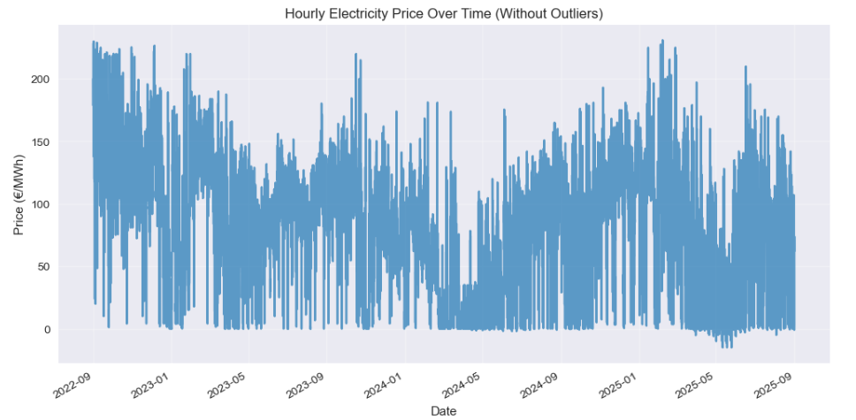
Figure 1. Hourly electricity price
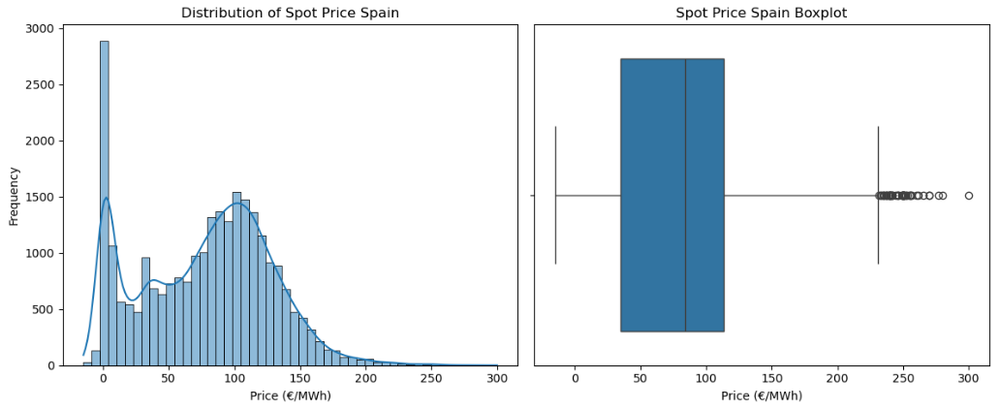
Figure 1 shows the evolution of the hourly day-ahead electricity price over the considered period. The series exhibits strong variability, with periods of elevated volatility alternating with more stable price levels. Thus, time and volatility aware modeling is necessary.
Figure 2. Distribution and Boxplot of SPOT price

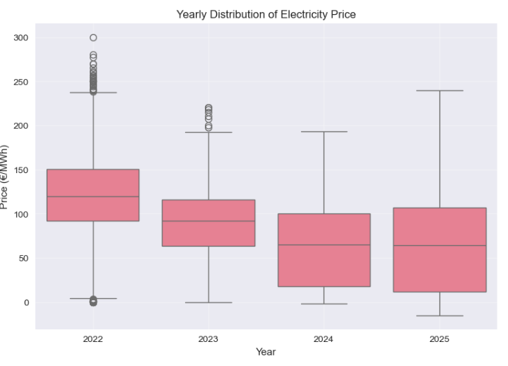
Figure 3. Yearly distribution.
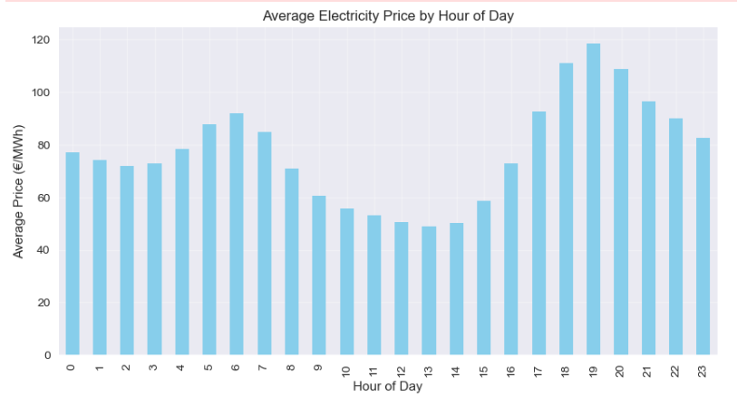
Figure 3 shows distribution the yearly distribution, by boxplots, of the electricity price revealing its central tendency and dispersion.
Figure 4. Average price by hour of the day.
For the figure above, a clear pattern within each day is observed. During midday prices are lower while they peak during the evening. This reflects the solar generation during noon hours and an increment in demand during the evening.

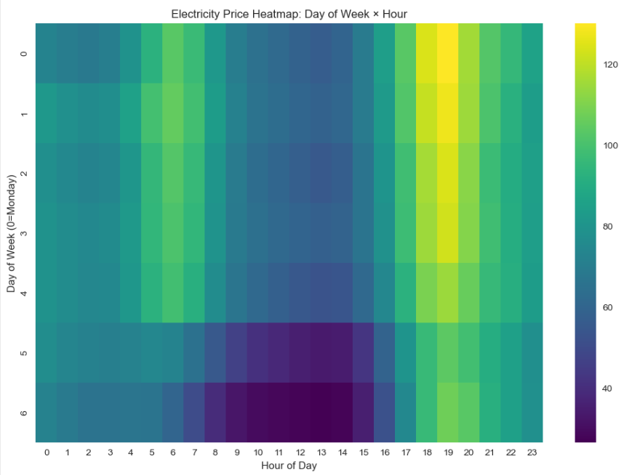
Figure 5. Day of the week by hour, price heatmap.
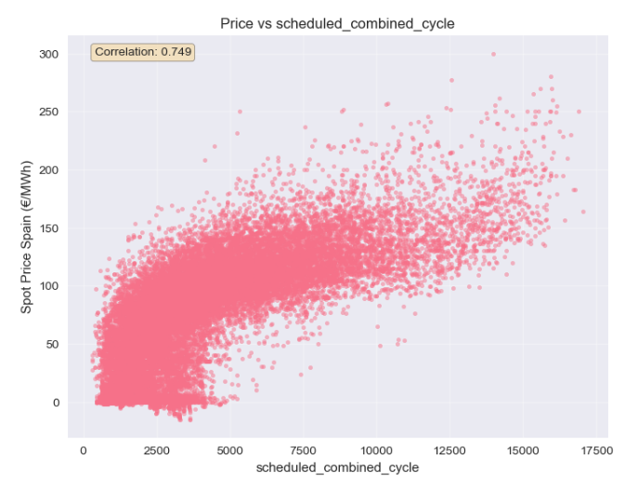
Figure 5 indicates how the above detailed intraday pattern interacts with weekly patterns, showing consistent evening peaks during weekdays and lower prices during weekend midday hours.
Figure 6. Scatter plot, price vs. scheduled combined cycle generation.

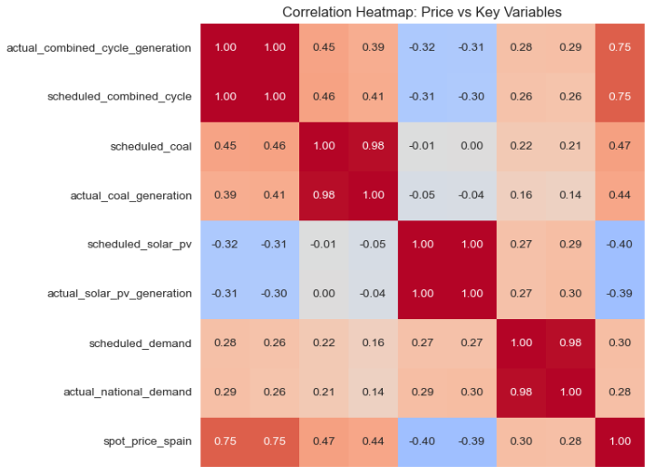
Figure 7. Correlation Heatmap: Price vs Key Variables.
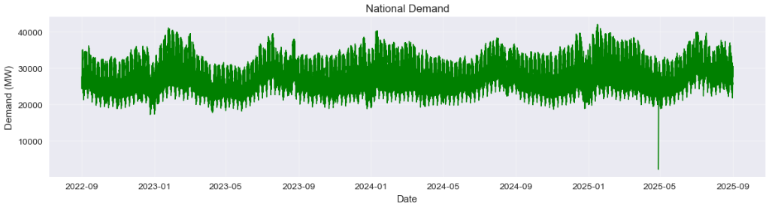
Figure 7 shows the correlation between the key variables selected, and figure 6 is a scatter plot between the two variables with greater correlation coefficient (scheduled combined cycle and SPOT price). The matrix confirms that thermal generation technologies are positively correlated with the price, while renewable generation exhibits a negative relationship. Scheduled variables are redundant with actual generation, thus making actual variables redundant in addition to not being available before the market closes. Demand shows only moderate correlation, indicating limited short-term price elasticity.
Figure 8. Electricity demand for the period considered.
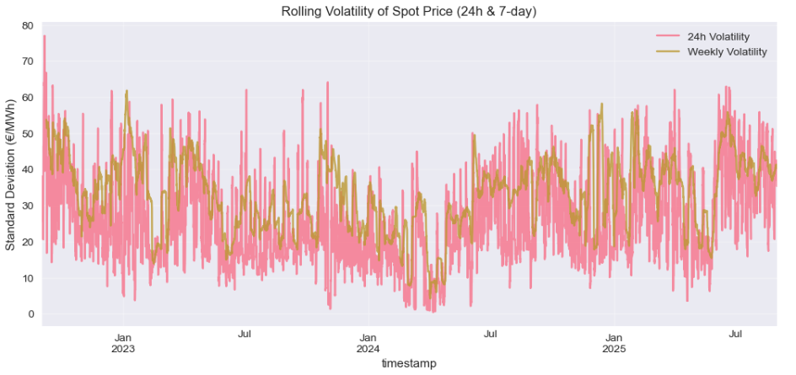
Figure 9. Rolling volatility.
Figure 9, Rolling volatility, highlights that electricity prices are characterized by a time-varying uncertainty. Short-term spikes are frequent, while weekly volatility reveals longer periods of market stress, reinforcing the need for a robust forecasting model.
For clarity, only a set of the figures made during the EDA task are included above. Additional figures, details and information can be found in the accompanying Jupyter notebook.

Key findings
The exploratory analysis reveals that Spanish day-ahead electricity prices exhibit a strong temporal structure across multiple scales. The EDA showed pronounced intraday patterns, with systematic price increases during evening hours and lower prices overnight and around midday. This behavior is clearly visible in the average price by hour of day and the weekday–hour heatmap. The observed temporal regularities justify the inclusion of calendar-based features in the model.
Combined-cycle gas turbines and coal-fired generation display the strongest positive correlation with prices, confirming their role as marginal technologies in the Spanish electricity market. In contrast, renewable generation—particularly solar photovoltaic and wind—shows a clear negative correlation with prices, reflecting their price-depressing effect during periods of high availability.
Electricity demand is only moderately correlated with price, showing its inelasticity and indicating that short-term variations alone do not affect the SPOT price. This confirms the nature of electricity consumption and the dominant role of the generation mix in setting prices.

Spot electricity prices show strong autocorrelation, confirming a temporal persistence in prices and supporting the use of lagged price features.
Missing values, zero entries, and anomalous observations were identified and quantified across all variables during the EDA phase. After applying the preprocessing steps described previously, no critical data quality issues were found that could compromise the validity of the forthcoming tasks.
Overall, the exploratory analysis highlights that electricity price formation in the Spanish market is primarily driven by temporal patterns and the marginal generation technology, rather than by demand alone. These findings directly informed the feature engineering process, the choice of lag structures, and the design of both the supervised learning and clustering methodologies presented in the following sections.

Machine Learning Model
Once the EDA was finished, it help with the feature selection analysis. A Pearson correlation analysis confirmed that lagged prices are the strongest predictors of the spot price, with the 24-hour lag showing the highest correlation. And among fundamental variables, scheduled combined-cycle generation exhibits a strong positive correlation with prices, confirming its role as the marginal technology in the Spanish market. Renewable generation variables, particularly scheduled solar PV and wind, display a consistent negative correlation with prices, indicating their price-depressing effect and demand variables show only moderate correlation with prices.
Based on these results, a reduced and interpretable feature set was defined, prioritizing lagged prices, scheduled generation by technology, demand indicators, and temporal variables. Variables with weak correlation, high redundancy, or post-event availability were excluded from the final modelling dataset.
Using the selected feature set, multiple supervised learning models were evaluated under the same time-series and cross-validation. Their performance was assessed primarily using RMSE, complemented by MAE and R².
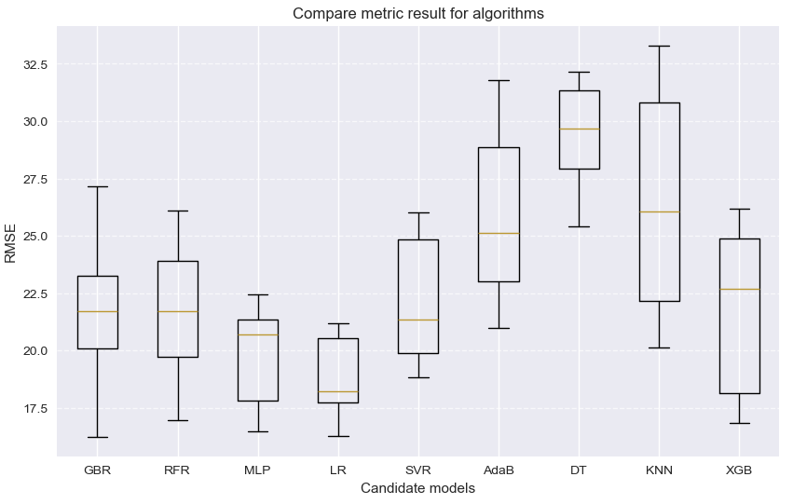
Figure 10. Possible predictive models
Figure 10 compares the distributions across the validation for all candidate models. Linear Regression consistently achieved the lowest average error and exhibited stable performance across folds. More complex models did not show better performance, indicating that complexity does not necessary translate to better results for the present project.
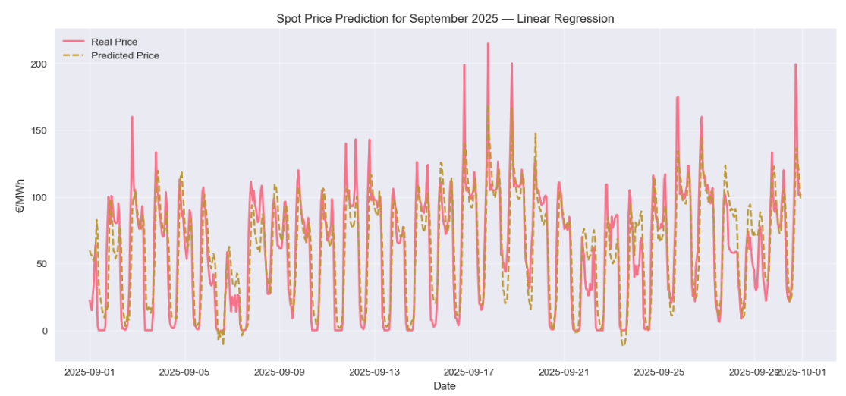
Consequently, Linear Regression (LR) was selected as the baseline forecasting model due to its strong performance and stability. The selected Linear Regression model achieved an RMSE of 18.8, an MAE of 14.97, and an R2 of 0.79.
Figure 11. September 2025 prediction
After selecting the LR model, it was evaluated using the unseen test set of September 2025.
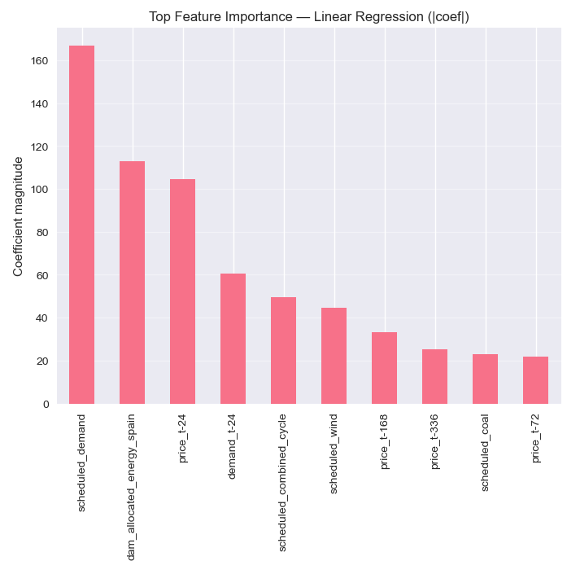
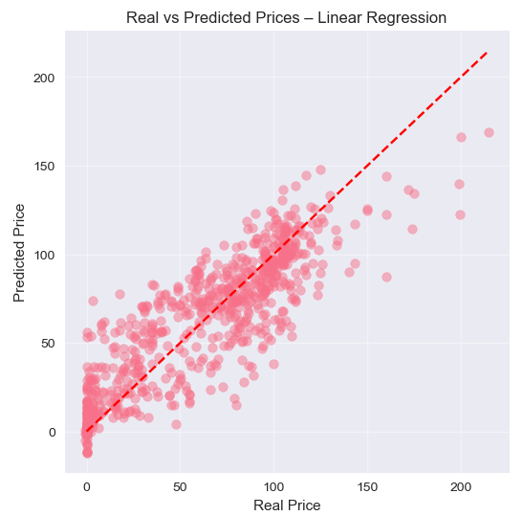
The model achieved an RMSE of 21.36, an MAE of 16.26, and an R2 of 0.752. Although performance decreases compared to the validation results, this is expected when moving from average folds to a real sample period. Figure 11 shows the above, the model captures the structure and overall price level, although some extreme values are underestimated.
Figure 12. Prediction evaluation

The scatter plot in Figure 12 confirms the quality of the model fit, with most observations concentrated around the ideal prediction line. And the feature analysis shows that lagged prices, scheduled demand, day-ahead allocated energy, and scheduled combined-cycle generation are the dominant drivers of price formation. These findings are consistent with the market mechanisms identified before.

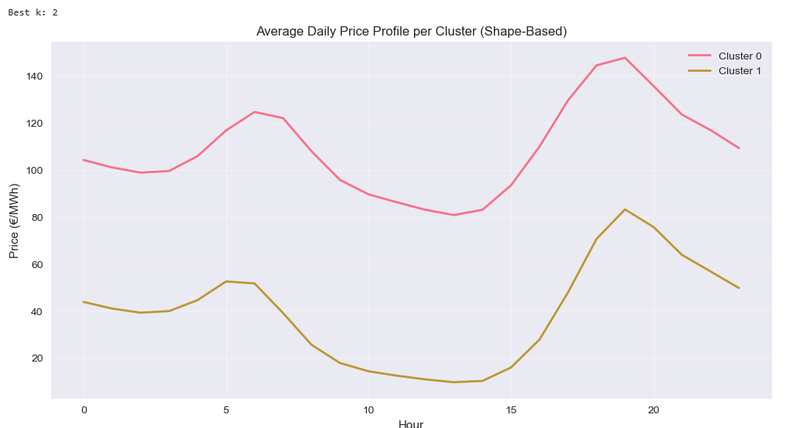
Clustering Daily Electricity Price Profiles
Figure 13. Price profile shape-based clusters
The shape-based clustering resulted in two dominant daily price regimes that share a similar intraday structure but differ significantly in price level. Cluster 0 represents a high-price regime, characterized by elevated prices throughout the day and a pronounced evening peak around 19:00. This profile is consistent with tight system conditions, where thermal generation is frequently marginal.
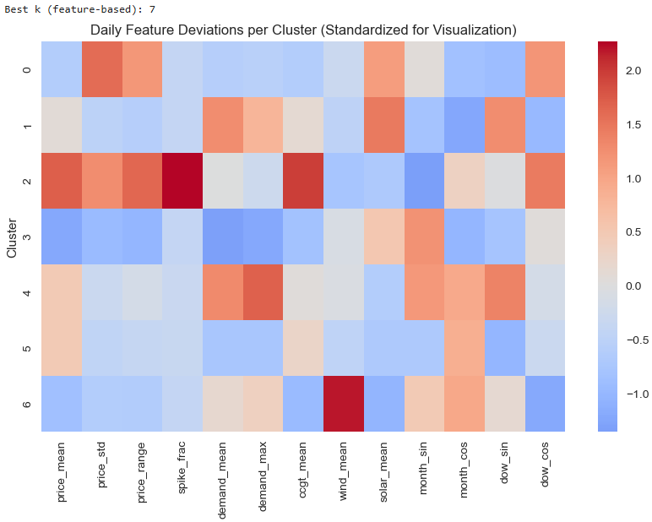
Cluster 1 corresponds to a low-price regime, with a strong midday price depression driven by high solar generation and a milder evening peak. These days are associated with higher renewable penetration and more relaxed system conditions.
Figure 14. Price profile feature-based clusters
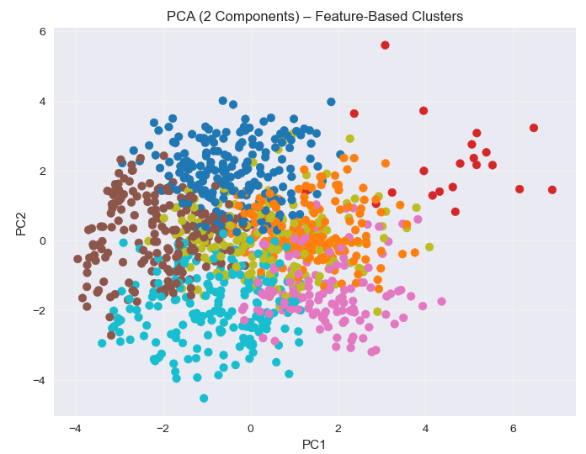
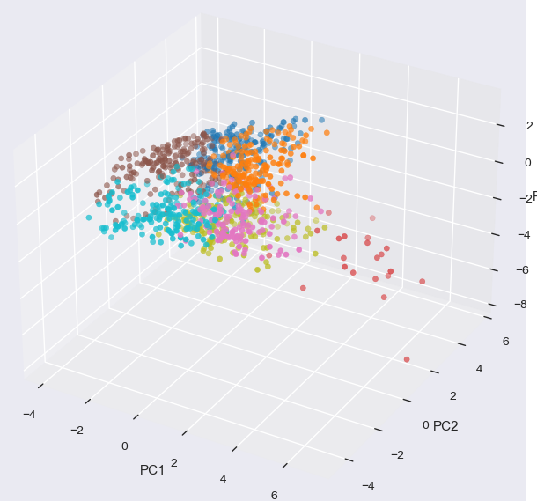
On the other hand, Figure 14 shows the feature-based clustering groups days according to daily aggregated market fundamentals. Several clusters correspond to high-stress system conditions, characterized by above-average prices, higher volatility and/or elevated demand. Thus, there is great reliance on combined-cycle gas generation. Other clusters represent renewable-dominated conditions, where high wind and PV generation leads to lower price levels and reduced volatility. These clusters are associated with more stable electricity market conditions.
Figure 15. PCA-Based Visualization of Feature Clusters
Figure 15 is a Principal Component Analysis (PCA) applied to the standardized feature space to visualize it better. The first principal component (PC1) captures overall system stress and price level, driven primarily by demand intensity and CC. The second principal component (PC2) is associated with the impact of renewable generation.

PCA for the regression model
Applying a PCA to the standardized input feature set resulted in 11 retained principal components, explaining 96.95% of the total variance. This indicates that PCA was able to compress the original 14-dimensional feature space while preserving most of the variability present in the data.
The transformed principal components were then used as inputs to a Linear Regression model, following the same training and validation procedure applied to the baseline model.
The performance of the PCA-based regression model was compared against the original Linear Regression model trained on the full feature set. The results obtained on the September 2025 test dataset are summarized below:

Linear Regression (original features):
- RMSE = 21.36
- MAE = 16.26
- R2 = 0.752
Linear Regression with PCA:
- RMSE = 22.49
- MAE = 17.21
- R² = 0.725
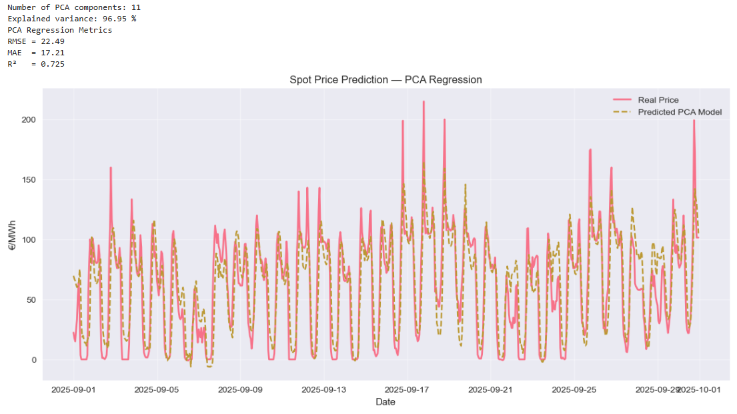Figure 16. Price prediction for PCA Linear regression

The PCA-based model exhibits a degradation in performance across all metrics. While the overall temporal structure is still captured, prediction accuracy is reduced compared to the base scenario. The PCA model is able to follow the general daily price pattern, However, it underestimates high-price peaks, and over-smooths low-price periods. The algorithm sensitivity is reduced greatly by the PCA implementation. The original features have clear physical and economic meanings, where they are transformed into abstract vectors, thus weaking the direct relationship.
The use of PCA for the regression does not improve the model’s performance, as the transformation removes relevant information implicit in the original features. The baseline LR model trained on meaningful variables provides a higher accuracy and stronger interpretability. PCA is not beneficial for this forecasting task, and the original feature-based regression model remains the preferred approach.

Conclusions
In this project, a comprehensive data-driven analysis of the Spanish electricity market was carried out using supervised and unsupervised machine learning techniques. The results demonstrate that careful feature engineering, combined with an appropriate time-aware validation strategy, is more important than model complexity for accurate electricity price forecasting. Linear regression emerged as a strong and reliable baseline model, while clustering and PCA provided valuable insights into market behavior and data structure. Overall, the study highlights the importance of combining statistical rigor, domain knowledge, and interpretability when applying data science methods to power system applications.

Challenges faced
Several challenges were encountered during the development of this project. First, the integration of multiple datasets from different sources required careful preprocessing and alignment to ensure temporal consistency. Second, the presence of missing values and zero entries in scheduled generation variables required assumptions that balance data completeness and physical plausibility. Finally, the strong temporal dependency of electricity prices imposed constraints on the validation strategy, limiting the applicability of standard cross-validation methods and increasing the complexity of model evaluation.

